**The Recruitment Methods of Tesco Plc**

**Introduction to Tesco PLC:**

Established by Jack Cohen in 1919, Tesco PLC has grown into a multinational retail conglomerate with operations across multiple nations. With its headquarters located in Welwyn Garden City, England, Tesco has expanded from small beginnings to become one of the biggest and most prosperous retail chains in the world. With a long history spanning more than a century, Tesco is still dedicated to offering millions of consumers globally premium products and first-rate service.

Tesco PLC manages a wide variety of retail spaces, such as convenience stores, supermarkets, hypermarkets, and online marketplaces. Tesco provides a broad range of products to satisfy the needs of its consumers, whether they are for food, household goods, apparel, electronics, or financial services. Tesco focuses on accessibility and cost to provide value and convenience.

**Why would Tesco recruit?**

Tesco may hire new workers for a variety of reasons, but addressing staff mix is a key consideration. There are many different reasons why employees leave their jobs, including personal situations, career progress, Death, and relocation. Tesco wants to fill these positions as soon as possible to preserve operational effectiveness and guarantee flawless customer service. Additionally, hiring more staff is crucial to meeting the rising demand and upholding good service standards if Tesco is growing its commercial operations, whether through the opening of new stores or the diversification of its offerings. Consequently, Tesco uses recruitment as a strategic drive to restock its personnel and further its goals for continuous development and expansion.

Tesco may also hire new staff members to infuse the company with new ideas and abilities. Maintaining creativity and flexibility in a cutthroat retail environment is essential for long-term success. Employing people with a variety of experiences and backgrounds allows Tesco to encourage innovation, creativity, and problem-solving among its staff. Additionally, new hires can have knowledge or abilities that improve Tesco's product line, customer service, or operational effectiveness. Tesco's personnel are reinforced by its recruitment practices, which also improve the company's capacity to adapt to changing consumer tastes and market trends.

**Tesco Internal Methods of Recruitment:**

Tesco is a worldwide retailer that uses a variety of internal hiring practices to fill open positions. First off, before positions are publicly announced, Tesco frequently uses internal job posts or vacancy announcements to let current staff apply for new positions. This promotes professional advancement within the company and employee development. This approach has the benefit of encouraging loyalty and morale among current staff members, who perceive prospects for advancement within the organisation. However, as it mainly seeks candidates who are already acquainted with the company, a drawback can be the possibility of less diversity in the application process.

Another internal method of recruitment that Tesco may use is if someone higher ranking in the business decides to retire at 67 [The national retirement age] then they advertise the job opening within the business such as a manager position or Shift manager etc to the normal employee’s to allow them to apply for the position of manager.

Tesco PLC, a leading retailer, strategically recruits based on a diverse array of factors to ensure its workforce meets the evolving demands of the market. Firstly, the opening of a new branch necessitates fresh talent to spearhead operations and uphold the company's standards. This presents an opportunity for Tesco to seek individuals who thrive in dynamic environments, possess strong leadership qualities, and are adaptable to change. By recruiting strategically for these new branches, Tesco ensures a seamless transition and maintains its commitment to excellence in customer service.

**Tesco External Methods of Recruitment**

Tesco uses a range of outside recruitment strategies to entice skilled workers to join the company. One popular strategy is the use of internet job portals and recruiting websites, where Tesco posts job openings in order to reach a large number of prospective applicants. This approach has the benefit of being widely accessible and reaching, as it enables Tesco to recruit people from a variety of backgrounds and places. The possibility of intense rivalry is a drawback, too, as well-known job boards frequently have a large number of posts from other businesses, making it difficult for Tesco to stand out from the competitors.

Tesco also frequently interacts with job searchers on social media sites like Facebook, Twitter, and LinkedIn in order to advertise its career prospects. This strategy has the benefit of enabling Tesco to engage and communicate directly with candidates, which helps the company establish relationships and convey its employer brand in a unique way. The requirement for active control and monitoring of social media channels is a drawback, though, as unfavourable comments or false information can spread swiftly and harm Tesco's standing as an employer.

By Tesco using these methods of external recruitment this allows them to effectively employee from outside of the company.

**Recruitment Process:**

**Identify a Vacancy:**

**Create Job Description**

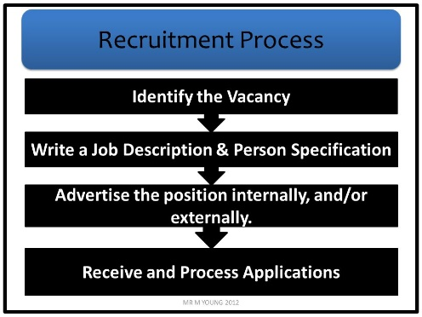**Create a Person Specification**

**Put ad on website.**

**Shortlist**

**Interview**

**Offer Job role.**

**Start Date + Contract.**

Legislation and ethics:

When Tesco PLC is hiring its employees there are certain Ethical Procedures and Laws they must follow when considering hiring an employee.

One of the Laws that Tesco PLC must follow when considering hiring is the Employment Act 2018. This act introduces new changes to protect employees against penalisation of their rights certain things that come under the employment act such as how Tesco PLC has a duty of care over their employees meaning to ensure the wellbeing of their employee’s and to ensure the safety of the people who work at Tesco. Another law that comes under the employment act is Policies and Procedures which means that the company [Tesco PLC] must produce polices the employees must follow and certain procedures for certain things such as maybe reporting a fellow staff member. The last thing to come under the Employment act is an Employee Contract. This is a contract the employee and the company must sign so the employee agrees to the terms and conditions of the business and that they also agree to all the policies and procedures they must follow.

Another one of the Laws that Tesco PLC must follow when considering hiring is The Equality act. This act makes sure you cannot be discriminated for certain things you have, or you have done to yourself, and The Equality Act covers Age: this is so no matter what age you are they can’t refuse to hire you or fire you over your age. Disability: This is so the employer cannot discriminate against you if you have any sort of disability whether it be a mental disability or a physical disability. Gender Reassignment: This protects you so if you have gender reassignment surgery or identify as a different gender this protects you against you being discriminated against by your employer or colleagues. Marriage and Civil Partnership: This protects you from being discriminated against because you are married or in a Civil Partnership. Pregnancy/Maternity: This protects you against any discrimination from your employer if you are pregnant. Race: This protects you from any discrimination by your employees or employer from being targeted because of your race. Sexual Orientation: This protects you from being discriminated against for identifying as a certain gender or sexual orientation. Religion/Beliefs: This protects you against being discriminated by your employer or employee’s from being a certain religion or believing in a certain type of God.

Another one of the Laws that Tesco PLC must follow is the National Minimum Wage 1988. Which makes it so Tesco must pay a certain amount of money to a person otherwise it is illegal. Below is a table of the national minimum wage over the past few years:

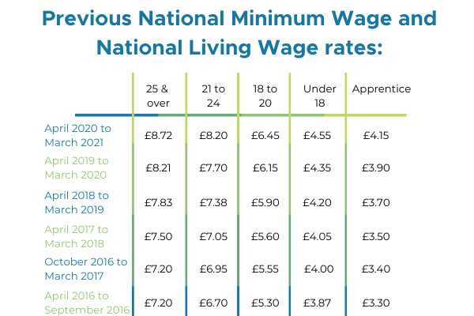

**Conclusion**

Tesco PLC, a worldwide retail powerhouse, lives on its painstakingly crafted recruitment processes, which are critical to the company's success. Tesco's approach is based on a dedication to diversity and inclusion, as evidenced by its efforts to attract candidates from all backgrounds. Tesco's competitive advantage is boosted by its diverse staff, which improves creativity, problem-solving, and consumer comprehension.

The company's recruitment process is known for its ease and accessibility. Tesco's online application system ensures that potential applicants may readily apply for vacancies from anywhere, hence boosting the talent pool. Furthermore, Tesco's use of behavioural interviews enables recruiters to assess candidates' fit based on their previous experiences and behaviours, providing significant insights into their potential performance within the organisation.

Tesco's dependence on competency frameworks is another important aspect of its recruitment approach. These frameworks define the important abilities and traits required for success in particular roles, allowing recruiters to objectively assess candidates. By aligning recruitment with these frameworks, Tesco guarantees that new personnel have the skills required to flourish in their roles and contribute effectively to the company's goals.

Employee referral programmes play an important role in Tesco's recruitment efforts. Tesco capitalises on its staff as a valuable source of talent acquisition by encouraging current employees to recommend eligible individuals. This referral-based method not only helps find people who will fit well within the organisation, but it also stimulates employee involvement and investment in the company's success.

Crucially, Tesco's dedication to continual improvement extends to its hiring practices. To keep up with changing market dynamics and internal needs, the organisation examines and refines its strategy on a regular basis. This agility enables Tesco to attract and retain top personnel in a competitive environment, resulting in organisational success and long-term sustainability.

To summarise, Tesco's recruitment processes are carefully adjusted to attract, select, and onboard outstanding employees who contribute to the company's growth and competitive advantage. Tesco maintains a strong talent pipeline by emphasising diversity, streamlining processes, behavioural interviews, competence frameworks, employee recommendations, and continual development, allowing it to prosper in the fast-paced retail market.

**References:**

[**https://slideplayer.com/slide/5713903/**](https://slideplayer.com/slide/5713903/)

**Tesco PLC (2023). About. [online] Tesco PLC. Available at:** [**https://www.tescoplc.com/about**](https://www.tescoplc.com/about) **[Accessed 15 Mar. 2024].**

**Wikipedia Contributors (2019). Tesco. [online] Wikipedia. Available at:** [**https://en.wikipedia.org/wiki/Tesco**](https://en.wikipedia.org/wiki/Tesco) **[Accessed 15 Mar. 2024].**

**www.equalityhumanrights.com. (n.d.). Marriage and civil partnership discrimination | EHRC. [online] Available at:** [**https://www.equalityhumanrights.com/equality/equality-act-2010/your-rights-under-equality-act-2010/marriage-and-civil-partnership#:~:text=The%20Equality%20Act%20says%20you**](https://www.equalityhumanrights.com/equality/equality-act-2010/your-rights-under-equality-act-2010/marriage-and-civil-partnership#:~:text=The%20Equality%20Act%20says%20you)

**‌**